**Documentation**

***About the module****:*

The purpose of this module is to produce comprehensive reports from HAAD survey data. The report engine is capable to import ASCII data directly which is using for a high level statistical data processing. User can extract statistical reports from this module by applying the available filters and having the freedom to export the output to excel format. An easy to use interface is the main advantage of this module.

We are mainly analysing following survey topics in this report module:

1. Q2. Work Environment
2. Q5. Evaluation Of Professional Performance
3. Q6. Experience & Achievements
4. Q7. Career
5. Q9. Innovation & Research Support
6. Q10. Work Schedule
7. Q11. Patient Care
8. Q12. Compensation & Benefits
9. Q14. Handling Challenges
10. Q17. Complaint System
11. Q18. Roles & Duties Abu Dhabi Regulatory
12. Q22. Collaboration & Support
13. Q23. Education & Training
14. Q24. Emiratis In Healthcare Career

Each of these topics is having their own elements (sub questions) and we are analysing those elements independently for finding an overall statistics. Each Element is having points as per their answers: Basic answer points are described below: All calculations in this report are as per the answer selection of survey respondents about these topics and each element in the topics.

|  |  |  |
| --- | --- | --- |
| **Answers** | **Agree / Disagree options** | **Satisfied / Dissatisfied options** |
| 5 | Strongly Agree | Extremely Satisfied |
| 4 | Somewhat Agree | Somewhat Satisfied |
| 3 | Neutral | Neutral |
| 2 | Somewhat Disagree | Somewhat Dissatisfied |
| 1 | Strongly Disagree | Extremely Dissatisfied |
| 9 | Not Applicable | Not Applicable |

***Main Screen of Report Module***

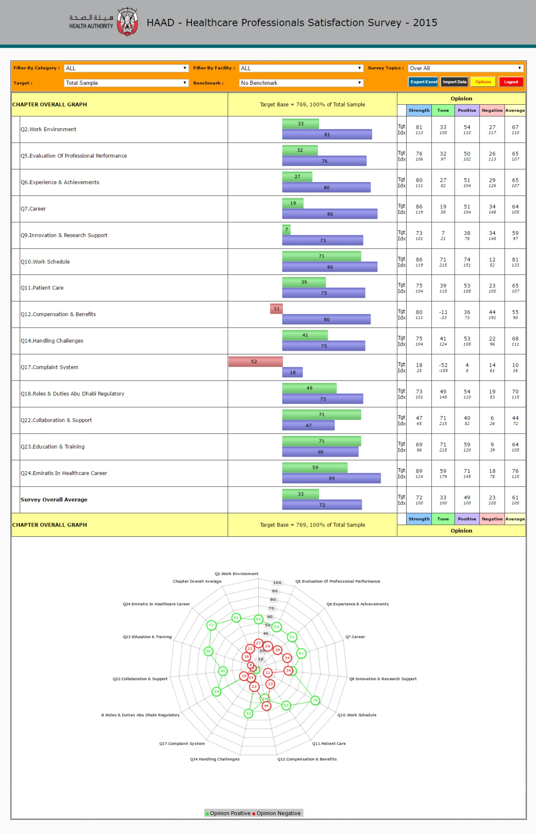

***Features of report module:***

1. Easy to understand Report
2. User can select survey topic for analysis
3. Analysis by Targets
4. Value Comparison by Benchmark
5. Filter data by Category or by Facility
6. Export Report to Excel
7. Import Data
8. User Options
9. ***Easy to understand Report: -*** HAAD Report module is outputting a very easy to understand reports in a user friendly interface. Reports consist of a Tabular format as well as in a Radar Graph format. Tabular format report is highly formatted with uniform colour codes and proper data headings for better and error free analysis. For easy analysis of Strength and Tone aspects we are using a Bar chart for each element in the reports. Calculations used in this reports are bellow:

|  |  |  |
| --- | --- | --- |
| **a.** | **Target Base** | *The count of respondents who are included in the report after applying the filters.* |
| **b.** | **Strength** | *((Count of Respondents who answered Any Agree + Count of Respondents who answered Any Disagree) / Total Number of Respondents by excluding Not Applicable Answers) * 100* |
| **c.** | **Tone** | *((Count of Respondents who answered Any Agree - Count of Respondents who answered Any Disagree) / (Count of Respondents who answered Any Agree + Count of Respondents who answered Any Disagree)) * 100* |
| **d.** | **Average** | *Average of answer points of each Elements after eliminating Not Applicable Answers* |
| **e.** | **Negative** | *(Count of Respondents who answered Any Disagree / Total Number of Respondents by excluding Not Applicable Answers) * 100* |
| **f.** | **Over All Average** | *Average of Strength, Tone, Average & Negative values of all elements from one topic* |
| **g.** | **Index Values** | *(Strength / Over All Average Strength) * 100*  *(Tone / Over All Average Strength) * 100*  *(Average / Over All Average Strength) * 100*  *(Negative / Over All Average Strength) * 100* |

1. ***User can select survey topic for analysis: -*** This feature allow users to select survey topic as per their interest. Apart from traditional report formats HAAD report module arranged the report by sections and provided the facility to choose the section of interest to load in the screen. So that detailed and focused analysis is possible for the researcher. Survey topic can be selected from the Survey Topics list on Top Menu of the screen.

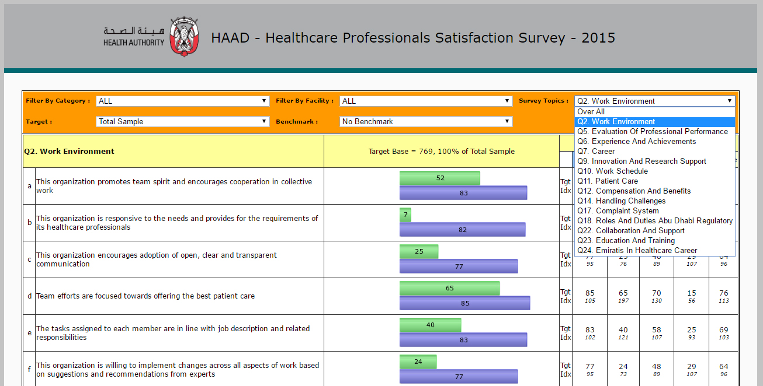

*Screen Shot of a Topic & Topic Selection menu*

1. ***Target Selection***: - The report analysis can be done on a particular predefined targeted audience. When user selects a target from top menu the report analysis will process as per that selection of audience. When you select target Filter option will disable.
2. ***Value Comparison by Benchmark***:- The statistical values in the report can be compared with a benchmarked targeted audience. This helps researcher to find the variations in the values easily. Benchmark values will identified by the tag Bmk in the report.

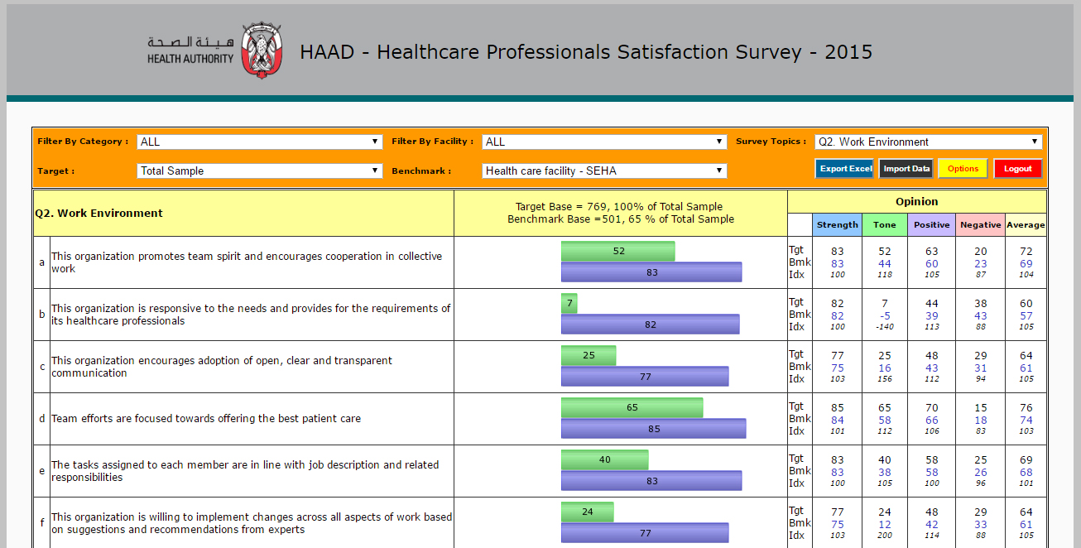

*Screen Shot of Analysis with Benchmark option selected.*

1. ***Filter Data by Category: -*** For detailed evaluation of any data: filter portion is very essential. Here in HAAD report module we have provided two filter conditions to choose as per user requirement. ***1)*** *Filter by Category and* ***2)*** *Filter by Facility*. When user chooses these filters then the data in entire report cube will get filtered as per the selection and the report will be refreshed as per the filtered data.

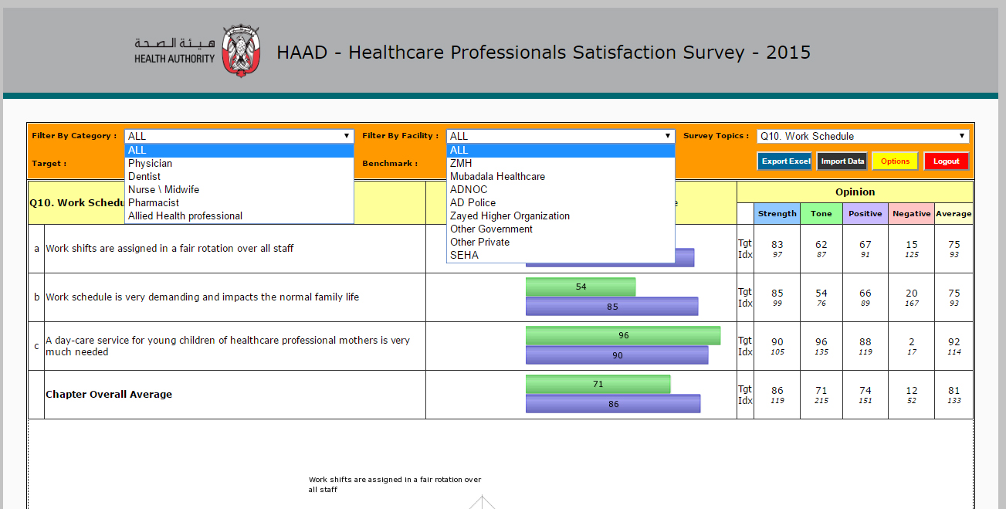

*Screen Shot of Filter menus*

1. 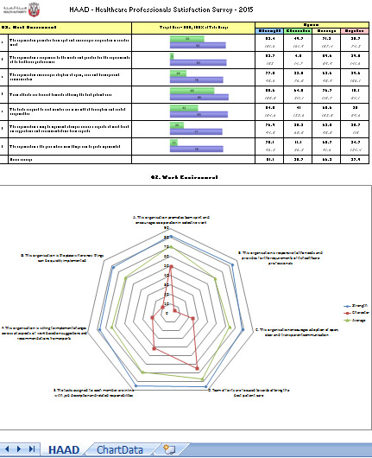**Export Report to Excel: -** HAAD Report module is giving the users the freedom of Exporting Reports to their favourite Microsoft Excel Platform. This export is possible in a click of button. You can click on “**Export Excel**” button on the right top corner. Exported report will be in Excel 2007 format. Radar Chart in this report is editable and the data set is attached in the excel file as a worksheet named “ChartData”. Meanwhile Bar charts are embeded images and non eaditable.

1. **Import Data**: - We can import ASCII data to the report module. You can click on “**Import Data**” button on the right top corner. Choose your file and click on Submit button for importing that data. Import module will clear all current data and will keep only newly imported dataset.

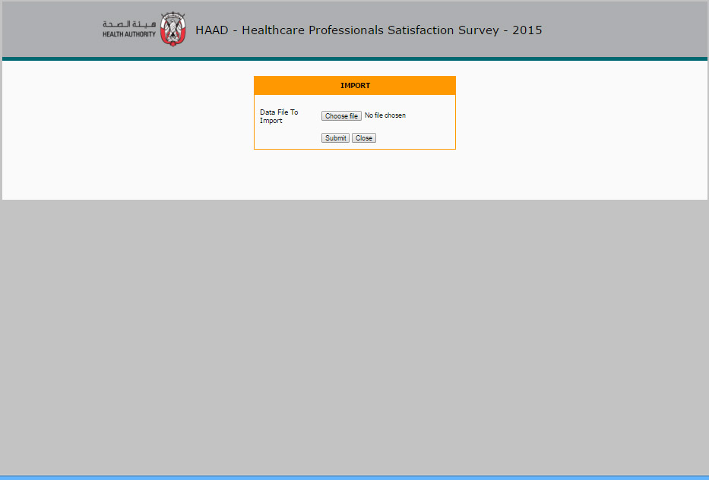

1. ***User Options***: - Here user has the freedom to change password as well as to set what all columns need to visible in the reports. User can also select whether they need Radar or Bar chart in the report. All selected options will remember for each user for their next login.

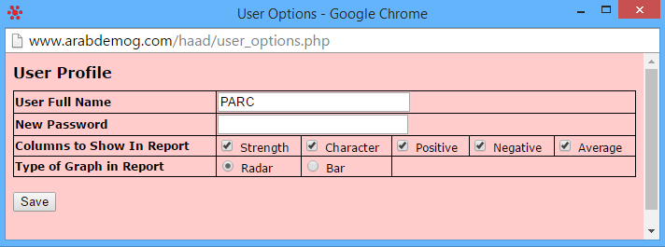

**Notes**

Link to access the HAAD Report module: <http://www.arabdemog.com/haad/report.php>