PARC - AD Log

A web based AD gallery through which users can search their Ads and can purchase / order it online.

Ads are categorized in to TV, Newspaper, Magazine and Online Ads. User can make a simple search over the data as well as a customized advanced search. The interface is very simple and provided with less graphics so the users should not wait for a long for getting a response. The simplicity and easy to use will be the main features of the system. System will also have an administration section through which administrator can control user access and also can monitor user activities.

We are using LAMP technology which is considered as most fastest and reliable technology over the web. The maintenance will be very easy as it is using macromedia templating system. Users can use this application in any browsers like Internet explorer, mozila, opera, google chrome etc.

How Ad log is working
User search
TV Ads
Newspaper Ads
Magazine Ads
Online Ads
Search Results
Members
of PARC ADLog
View full details
View ADs
View TV Ads
Export Data
View thumpnails of ADs
Online purchase
Request for membership
Yes
No
How data access is controlling.

For each user we can make their access limits- over Ad type, markets, categories, sectors, products, brands and medias. But this access limit is possible only for our members. For a guest he can search over our entire data, but he can search only for a specific period as well as he will not get the options to export data, he can view only the thumbnail images. A guest will not get detailed information on an AD. But he can check whether that Ad is existing with us or not, he also having an option to buy those Ads by using our online payment system.

Features of System

Key feature:

- Simplicity in user level
- Platform independent
- Speed in performance
- Save option for Advanced Search
- Search refine option over search results

Technical features:

- Administrator’s Control panel
Functions:
  - User creation as per the requests received
  - Access control
  - Member ship card updation
  - Manage Auto Alerts, newsletters etc
  - Mass mailing option to members
  - Who is online
  - User activity monitoring
  - Daily Data uploads and updations
  - Master file updation
  - Update Announcements and News which can be flash on website
  - Can set auto mail reminders (eg: membership renewals, new data archive)
  - Data summary reports for downloads / uploads and availability status
  - Manage service requests
  - Support and feedback management

- User’s Area
Functions:
  - Sample search over data
  - Request for membership
  - Simple data search
  - Advanced data search
  - Save search
  - Download / Preview data as per their access
  - Ready made analytical reports over data
  - Data export utility
  - Membership upgrade option
  - Request for a service
  - Receive auto alerts, newsletters as per their interest
  - Suggestions / Feed back / complaint - reporting

- Supporting forums
Functions:
  - Post User’s comments
  - Post experts comments
  - Small Surveys over the product
  - Create a community over the product users

Screen Shots from Program

Home Page:

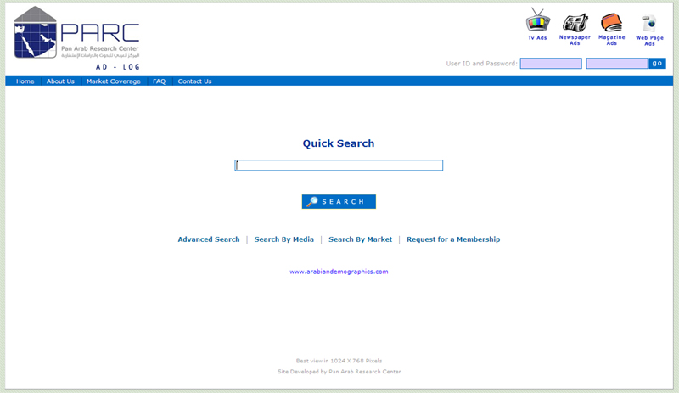

Search Result Page
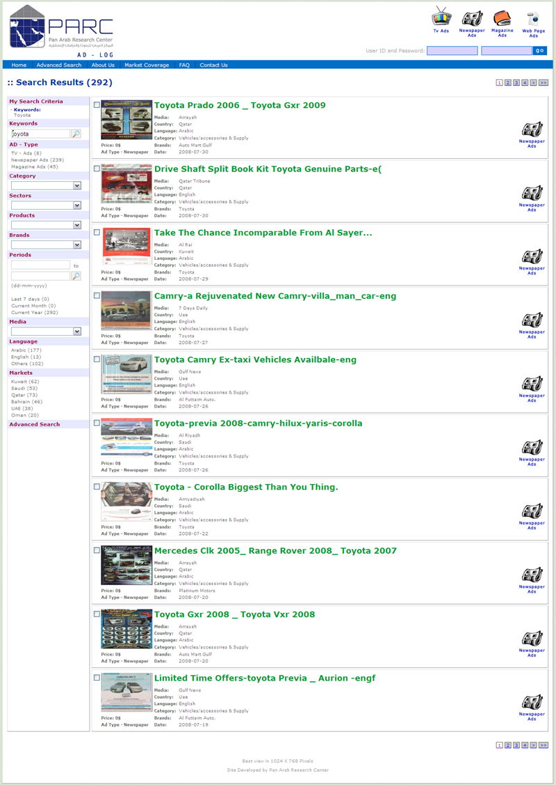
Advanced Search:

