PARC Report Gallery
Screen Mockups
Version 1.0

PARC Report Gallery

Contents:

The screen layout of this application can be mainly classifieds into two sections
- User Module Section

  - Home Page - Before Login
  - Home Page - After Login
  - User Registration Form
  - Advanced Search Form
  - Search Result Page
  - Repot Detailed View
  - My Order Status
    - Order Delivery Status Update
  - My Account
  - Change Password
  - Special Report
  - Suggestions & Complaints

- Administrator Module Section

  - Home Page - Before Login
  - Home Page - After Login
  - View Newly Registered Users
  - Manage Orders
  - Manage Category Master
  - Manage Region Master
  - Upload new Report

User Module

Screen Name: Home Page - Before Login
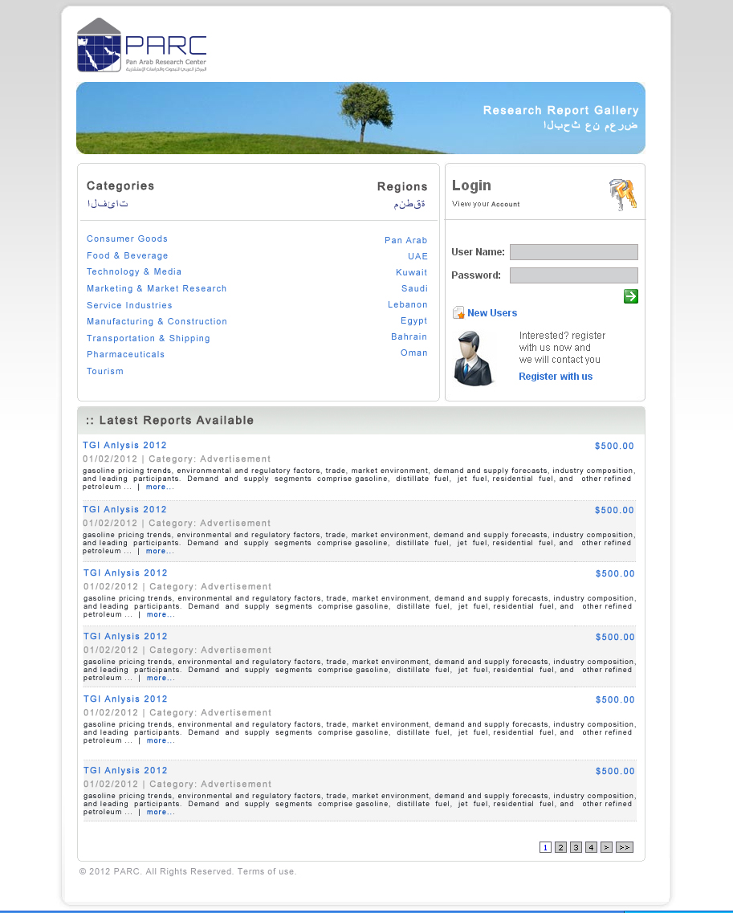
Comments:

Screen Name: Home Page - After Login
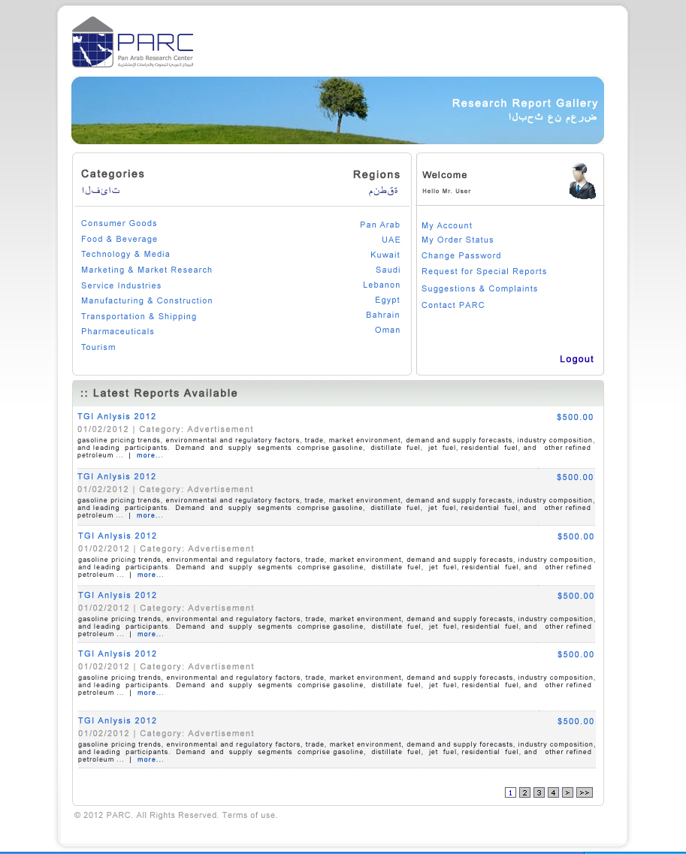
Comments:

Screen Name: User Registration Form
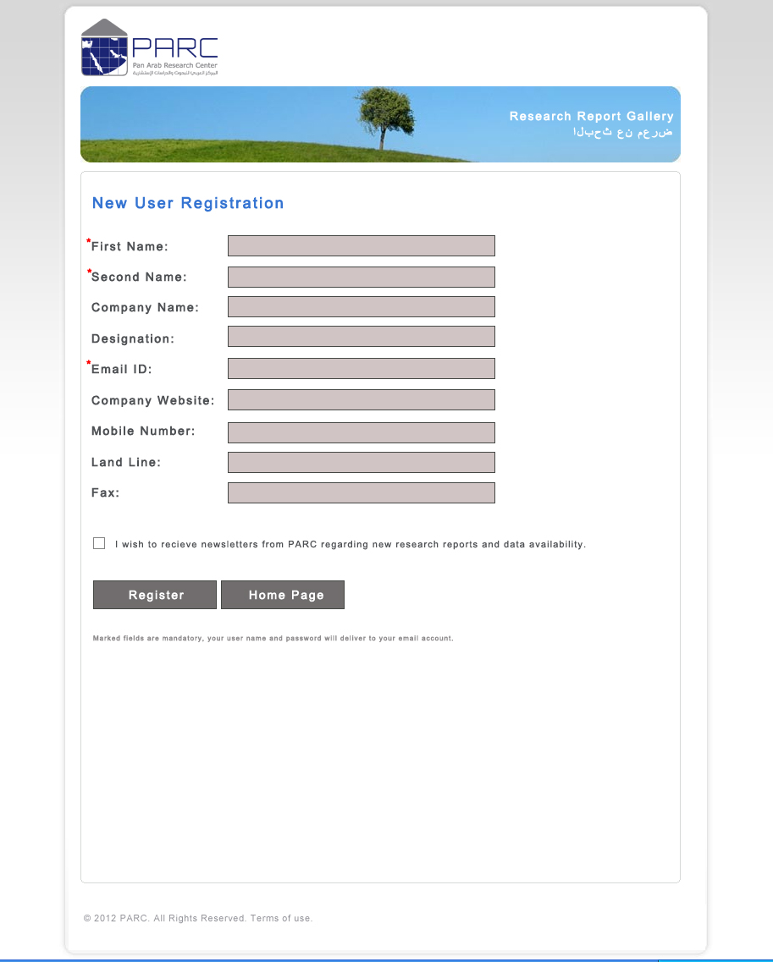
Comments:

Screen Name: Advanced Search Form
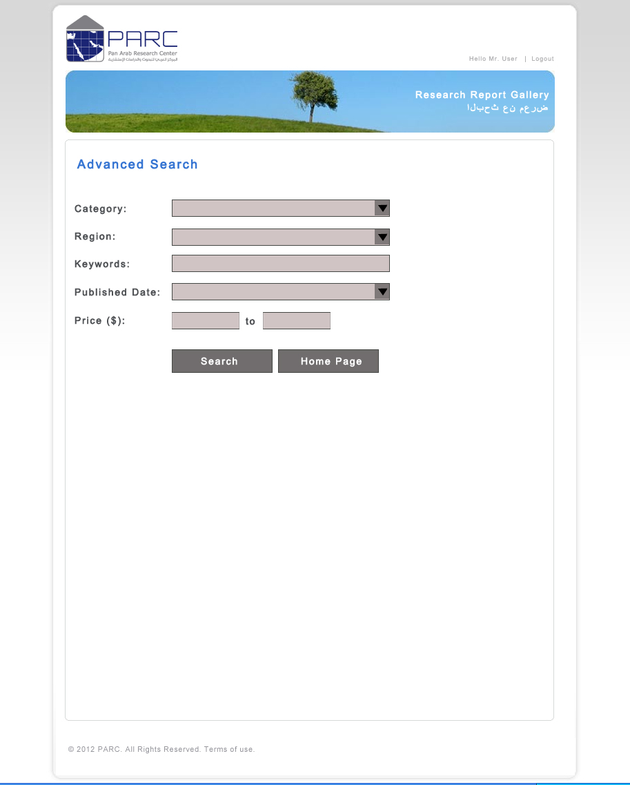
Comments:

Screen Name: Search Result Page
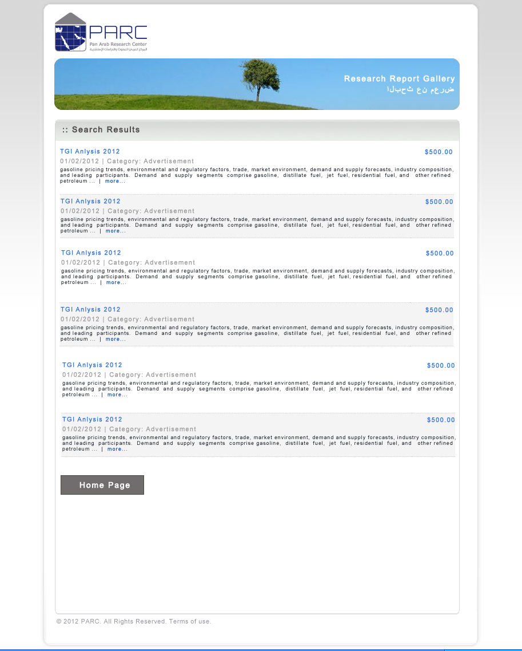
Comments:

Screen Name: Repot Detailed View
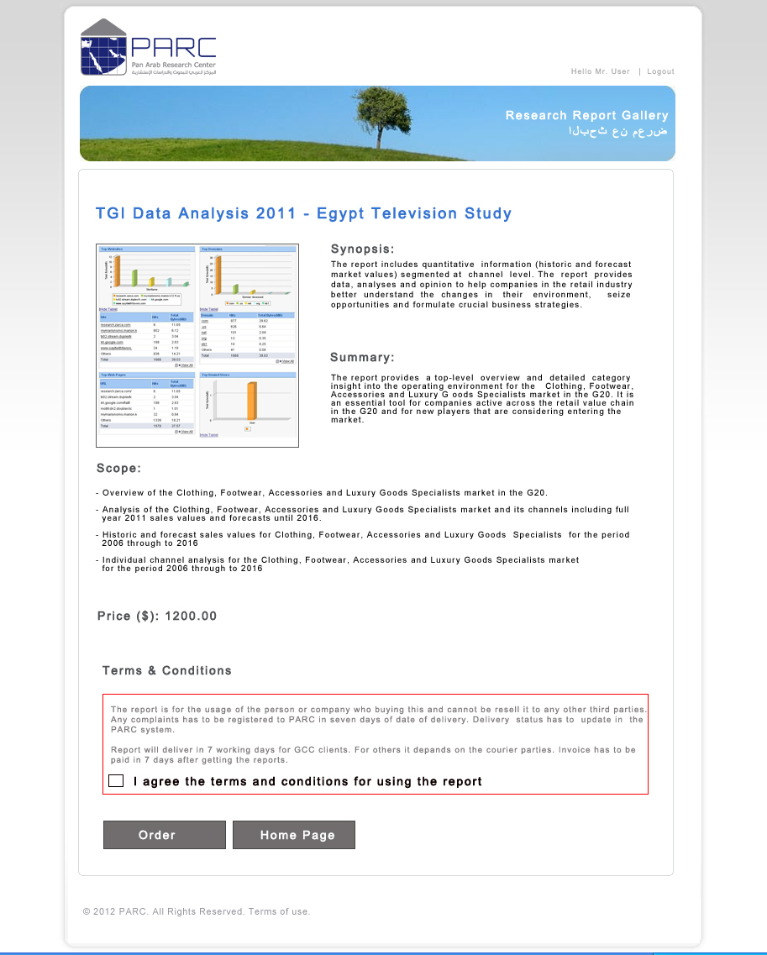
Comments:
Contents in Synopsis, Summary, Scope etc is capturing while uploading a new report to the system. The terms and conditions have to be defined by PARC and it will be a general format for all reports.

Screen Name: My Order Status
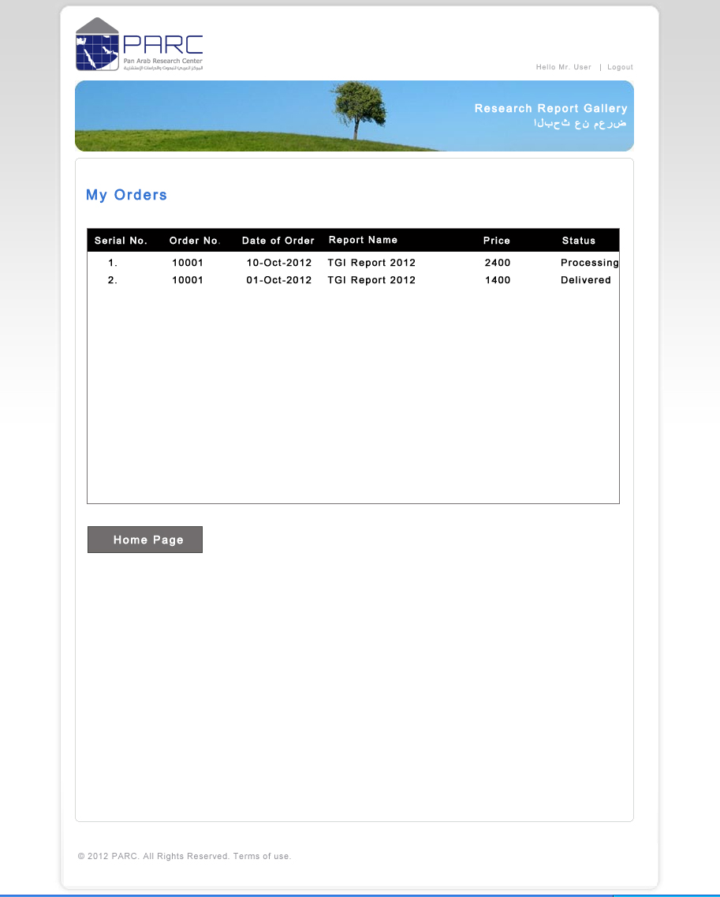
Comments:

Screen Name: Order Delivery Status Update
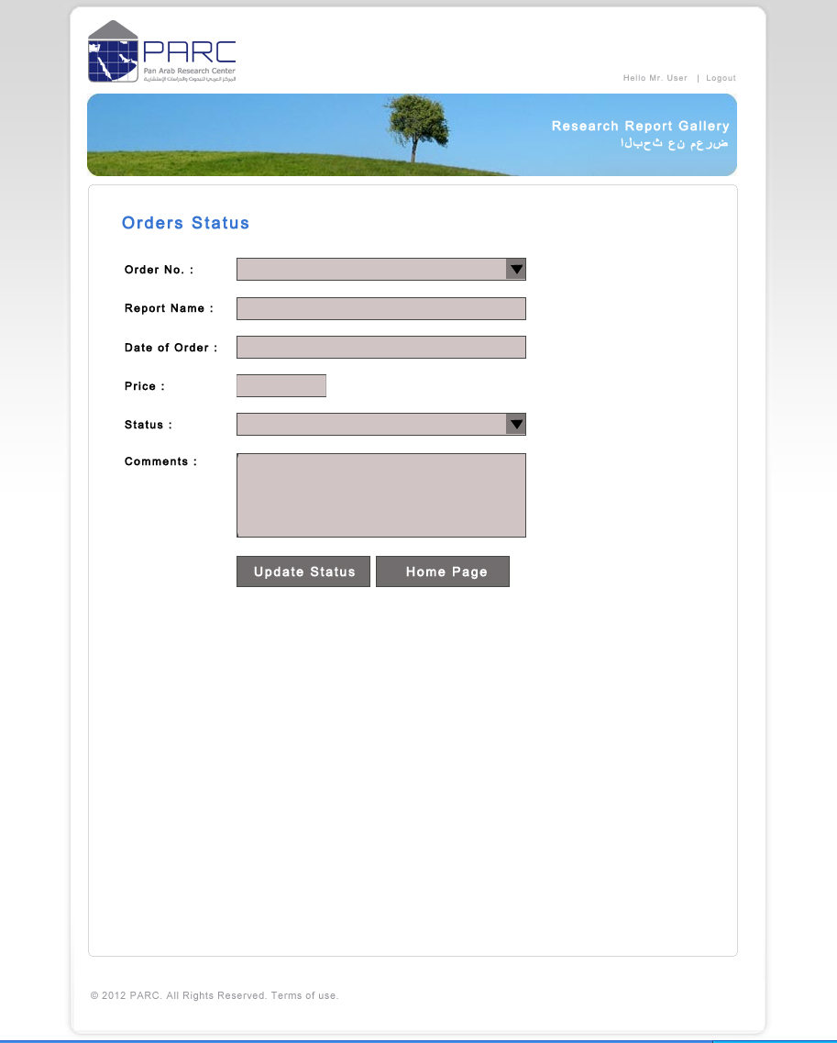
Comments:

Screen Name: My Account
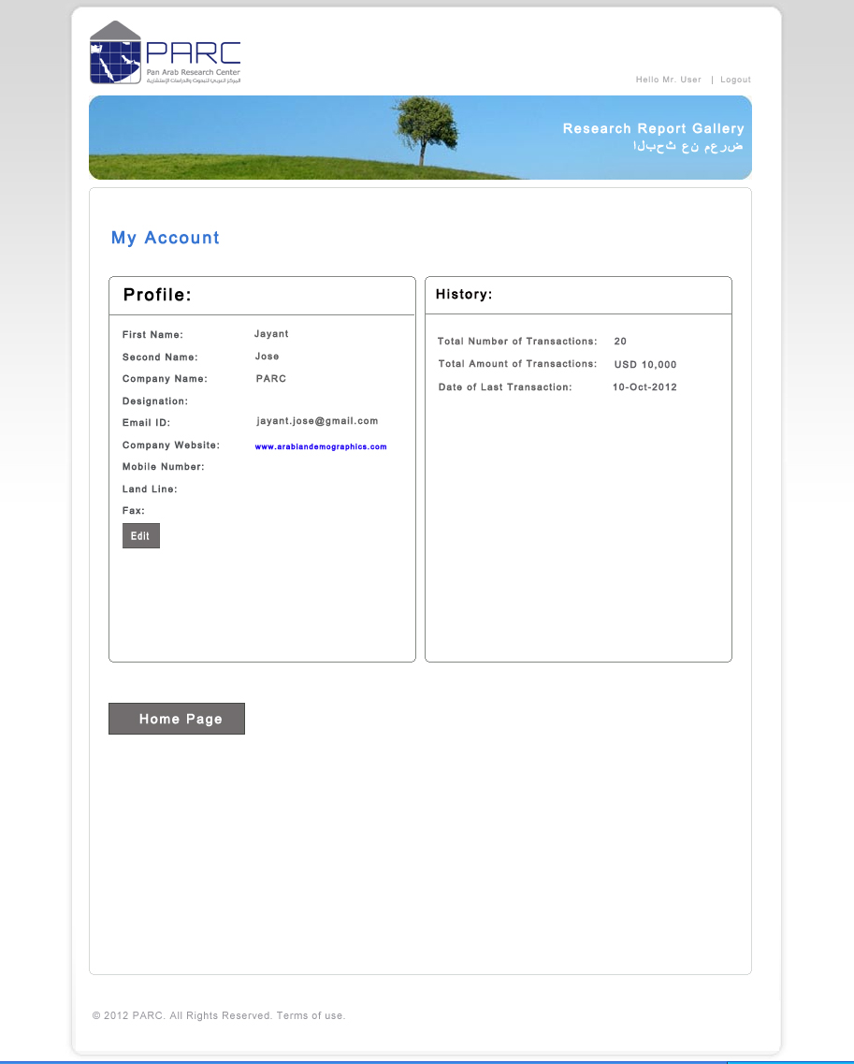
Comments:

Screen Name: Change Password
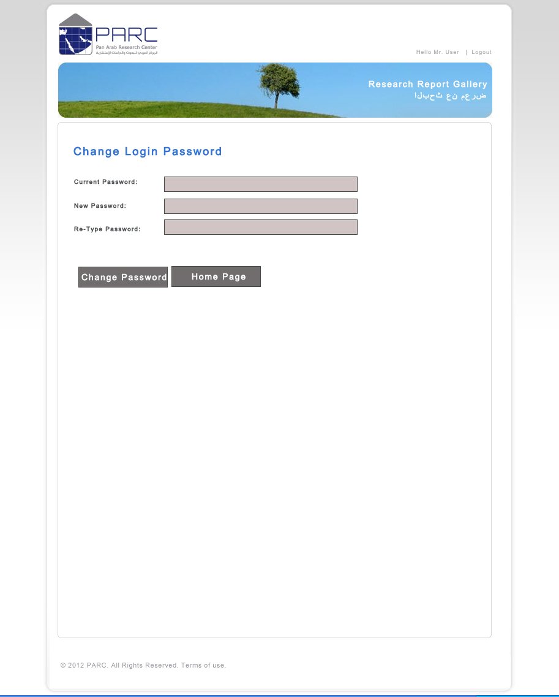
Comments:

Screen Name: Special Report
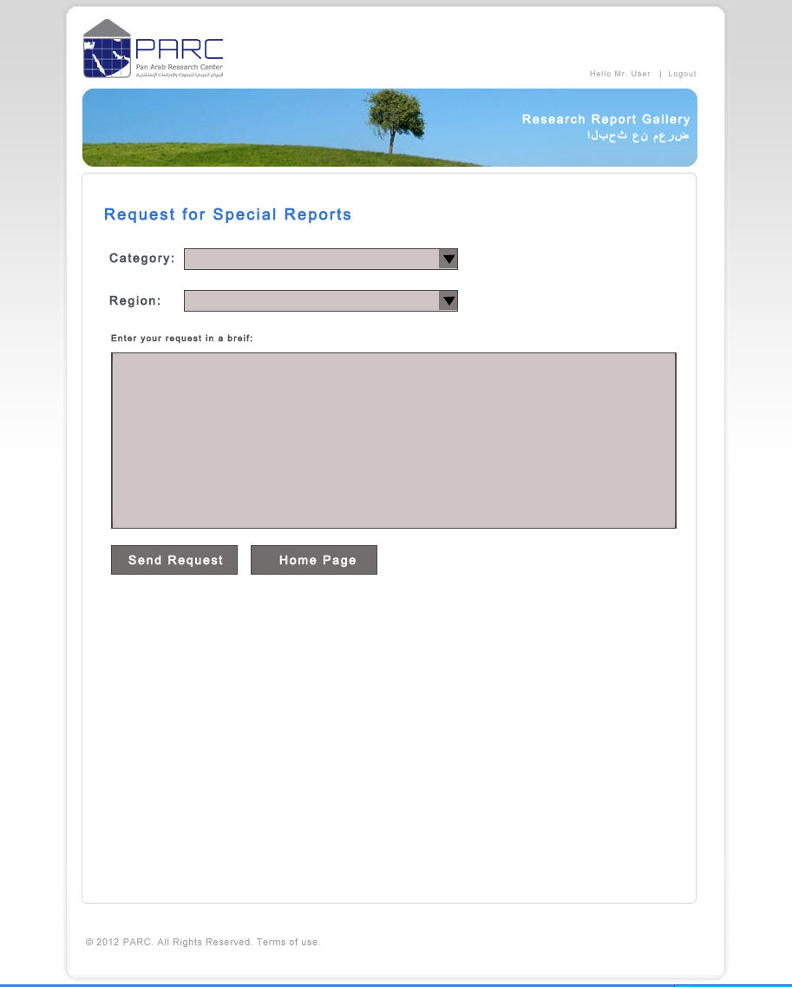
Comments:

Screen Name: Suggestions & Complaints
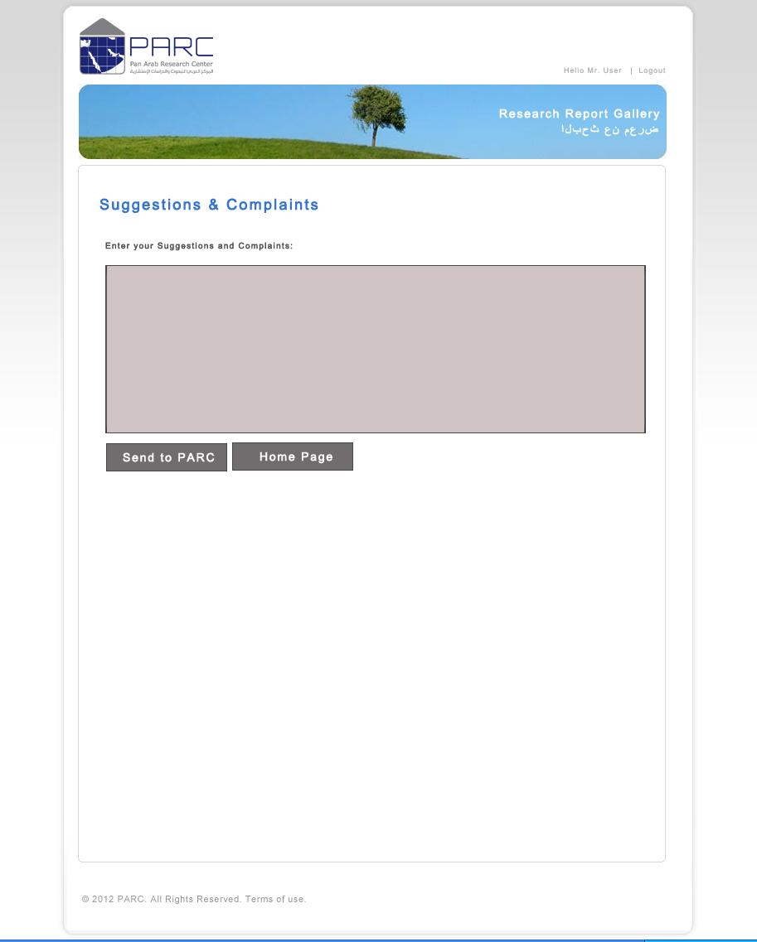
Comments:

Administrator Module

Screen Name: HomePage - Before Login
Comments:

Screen Name: HomePage - After Login
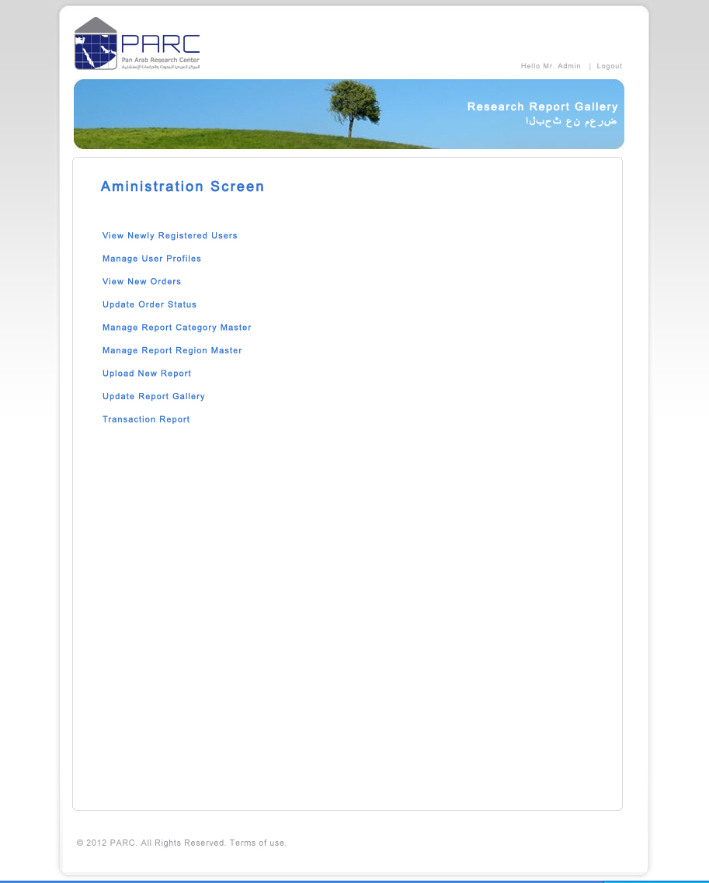
Comments:

Screen Name: View Newly Registered Users
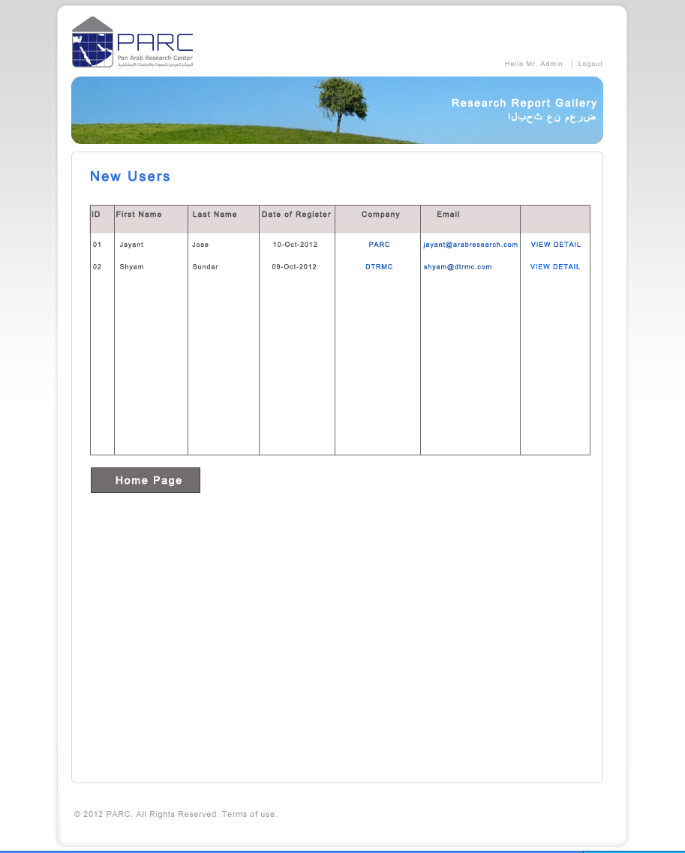
Comments:

Screen Name: Manage Orders
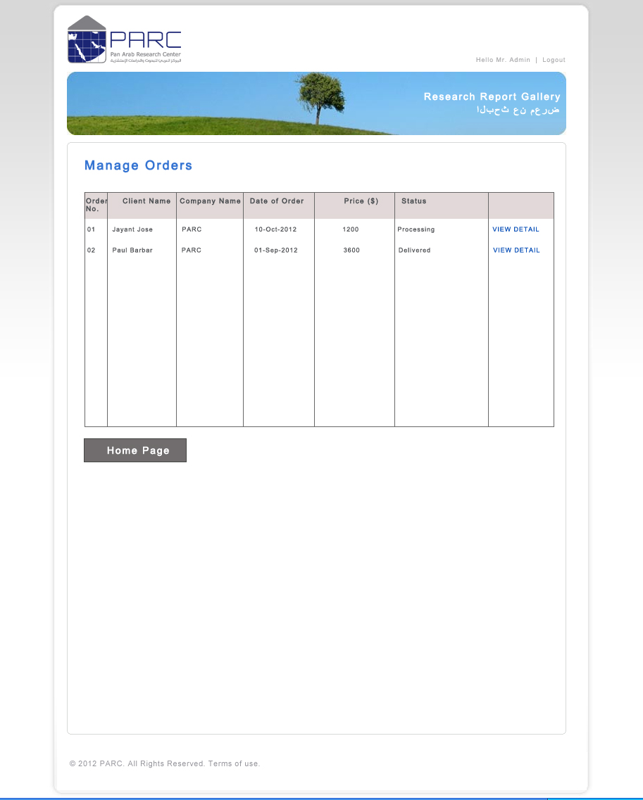
Comments:

Screen Name: Manage Category Master
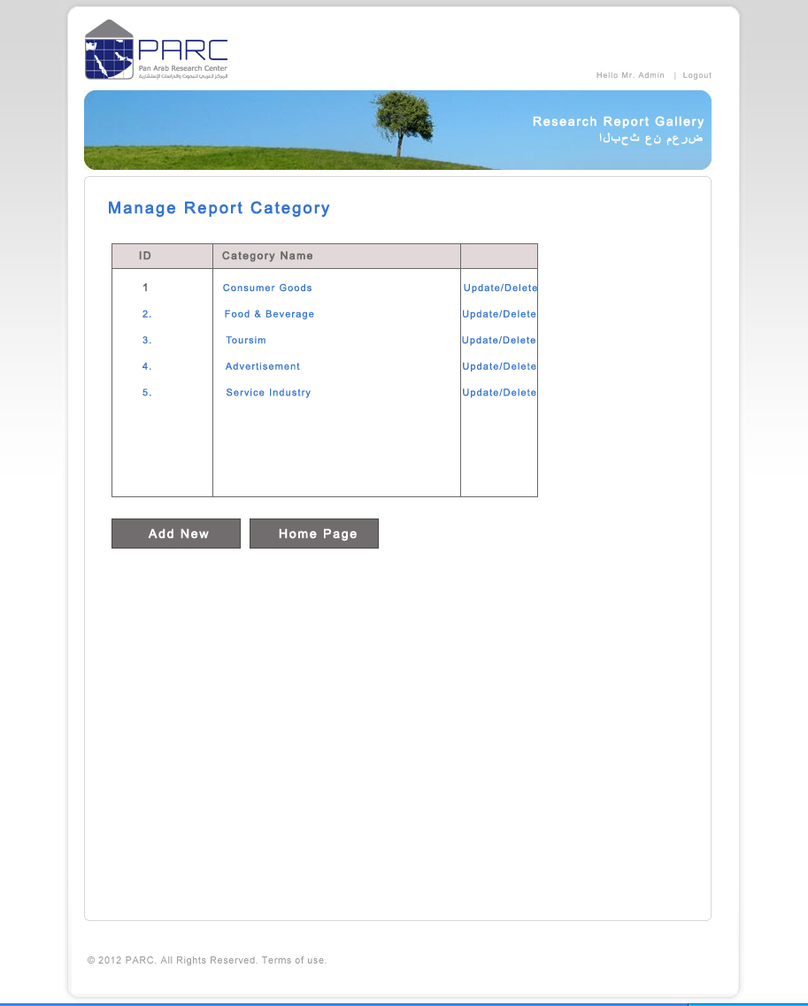
Comments:

Screen Name: Manage Region Master
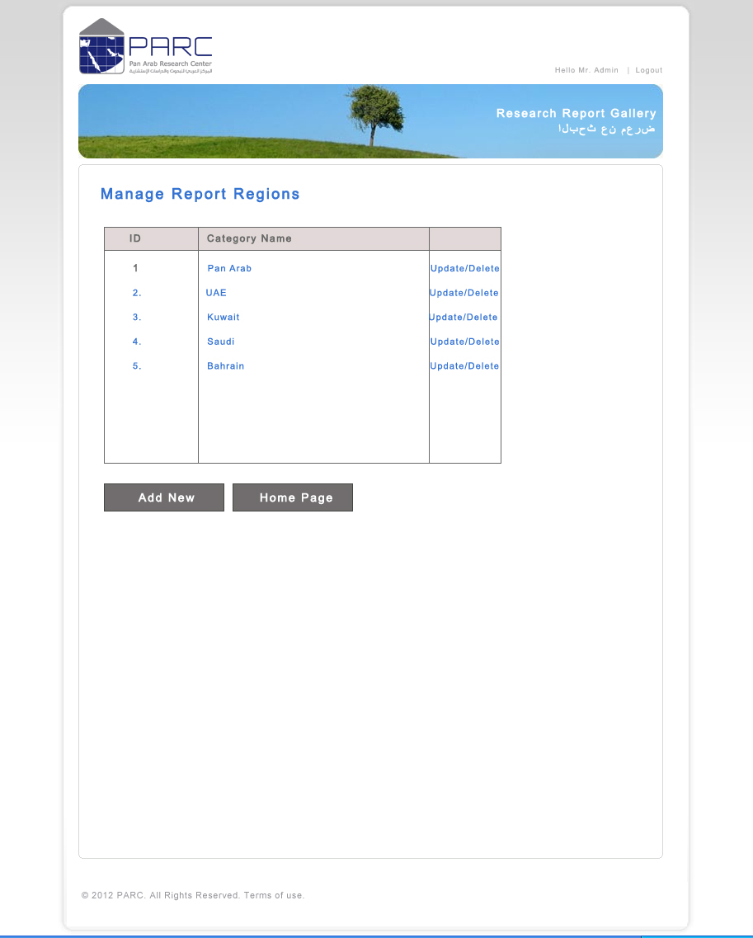
Comments:

Screen Name: Upload new Report
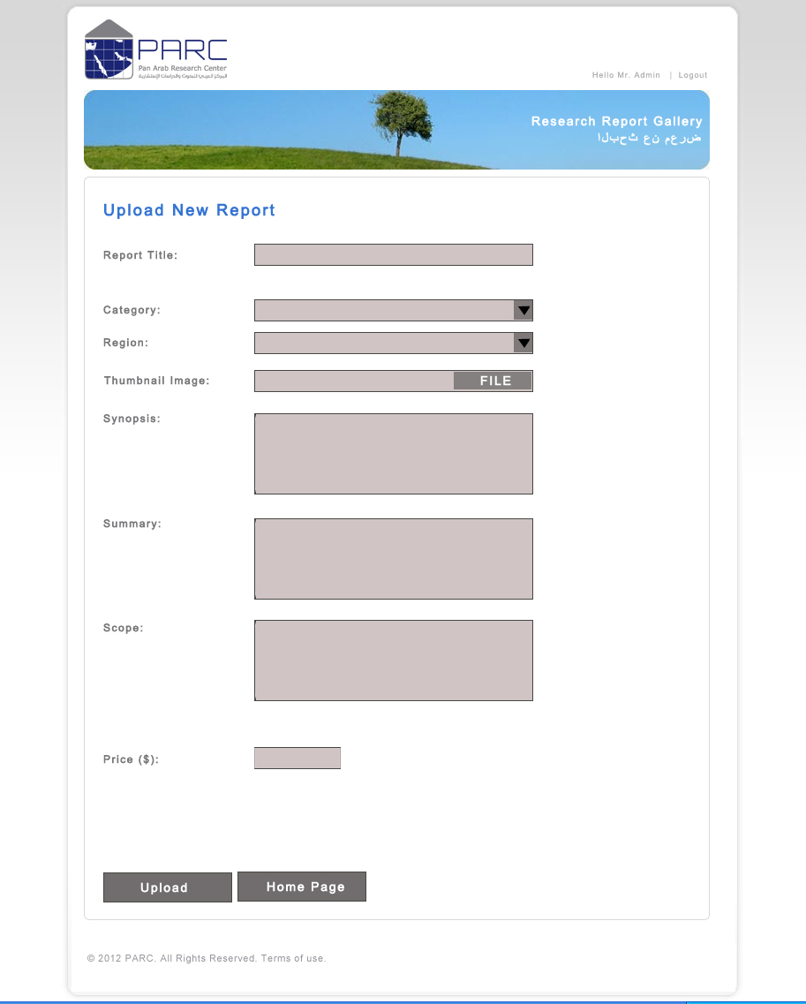
Comments:

